GeoGebra Into/ Circle Lab
Go through this lab. When you are working on the circle portion of the lab make sure you type your answers into the lab sheet as you will be uploading this lab sheet at the end of the lab. You will need to use the drawing tools in word to create pictures for some parts.
Intro
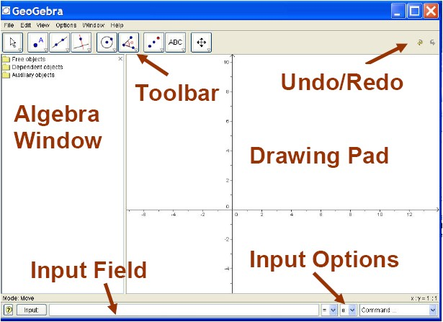
This is the GeoGebra screen and where different parts are located. The picture below review what each of the tools in the tool bar are for.
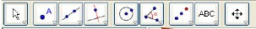
Selection tool | Point tool | Line tool | Parallel and perpen-dicular line tool | Circle tool | Angle tool | Reflection tool | Misc. tools | Moving tools

Take some time to go in and play with all the different tools and see how they work. Once you feel comfortable with the program begin the circle portion of this lab.

Circles
A circle is the set of all points in a plane at a given distance from a given point in the plane.
SKETCH
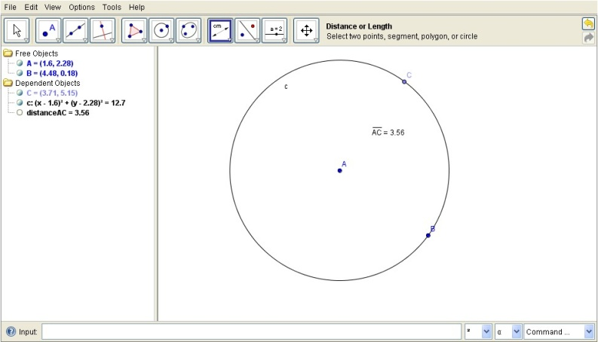
Step 1: Use the circle to construct a circle. The two points (A and B in the diagram) define your circle. Use the selection tool to drag each point to see how it affects the circle.

How does dragging the center point affect the circle?

How does dragging the point on the circle affect the circle?

A circle is usually named after its center point. In the diagram above the circle would be called circle A.
Step 2: Construct a point on the circle.
Step 3: Select the distance tool from the angle tool box. Now the point in the center of your circle and the new point you created on the circle.
Investigate
- Drag the new point you created around the circle. What do you notice about the distance that you measured? How does this observation relate to the definition of a circle?

- Under the line tool select the segment tool. Create a line segment from the center of you circle to one of the points on the circle. This segment is called a radius. Its length is also called the radius. You can change the radius of this circle by dragging the center point or the point on the circle. The distance measured from the center to the point on the circle is the length of the radius.
- Construct another circle using the same center your first circle. Drag the point on the new circle inside and outside of your first circle. If two or more coplanar circles share the same center, they are called concentric circles. How many circles can share the same center?

- Drag the new circle so that it lines up with the first circle. What do you notice about the length of the two circles radiis? Two or more circle are congruent if they have radii with the same length.

An arc of a circle is two points on the circle and the continuous part of the circle between them. The two points are called endpoints. $\hat{AB}$ or $\hat{BA}$ is the arc with points A and B as the endpoints.
SKETCH
Step 4: Clear your previous drawing and create a new circle. Create two more points on the circle.
Step 5: Select the “circumcircular sector through three points” tool under the circle tools. Select in order the three points on the circle.
Investigate.
- The shaded area created is called a sector the portion that is just a part of the circle is called the arc. If the arc is less than half the circle it is called a minor arc, if it is more than half the circle it is called the major arc, and if the arc is half of the circle then you have a semicircle. Draw a picture of a major arc, minor arc, and a semicircle. Name the arcs correctly and explain why you should use three points when labeling a major arc or semicircle.

- Arcs have measures like angles and arc measures are also measured in degrees. Select the angle tool and then select the points in this order, one of your arc endpoints, then the center of your circle, and then the other arc endpoint. The angle created by these three points is called the central angle and the measure of this angle is the arc measure. Create a picture labeling the central angle and the arc it creates.

- Clear your drawing surface and create a new circle. Now create a second point on the circle. Use the segment tool to create a line segment between the two points on the circle. Drag the endpoints of the segment around the circle and observe its behavior. This line segment is called a chord. Chords are segments and should be labeled like segments. Write your own definition for a chord in an if-then statement, Then draw a picture with a chord in it.

- Drag your chord until it goes through the center of your circle. This is a special chord called a diameter. Write your own definition for diameter in an if-then statement.

- Now use the line tool to construct a line through the two points on the circle. This line is called a secant. Secants are lines and should be labeled like lines. Drag the points on the line around the circle and observe. Write your own definition for secant in an if-then statement.

- Line the two points on top of each other. This should look like the line is touching only one point on the circle. A line that touches only one point on the circle is called a tangent. Write your own definition for a tangent in an if-then statement.

