Creating A Quiz For Your Training Application.
Preparation:
1. Write a minimum of six multiple choice questions to test knowledge of OHS, that users of your program can use to test their understanding of your training program – THE PODCAST AND YOUR PRESENTATION.
Multiple choice question example:

2. If you are using images and/or sound in your questions:
i) Edit your sound files and save as .mp3 format
ii) Locate and resize your images – max size for use in questions is approx. 100x100
iii) Create a folder in which you will save your image files, sound files and Hot Potatoes files.
Online Quiz Development:
1. Download and install the Hot Potatoes quiz creation software from http://hotpot.uvic.ca/
2. Run Hot Potatoes and select JQUIZ
3. For your first question enter the, i) Stem ,ii) Correct Response, iii) Distracters’, and iv) Feedback.
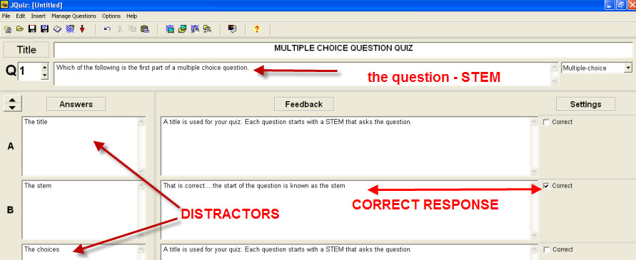
4. Repeat for your other questions.
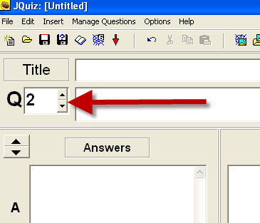
5. Save your quiz as a .jqz file.
6. Upload both files (.jqz and .html) to the subject Moodle for marking.
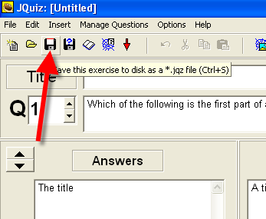
6. Export your quiz as a web page
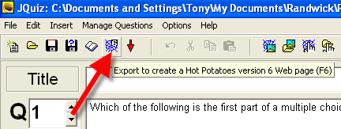
7. View and test your quiz in your browser
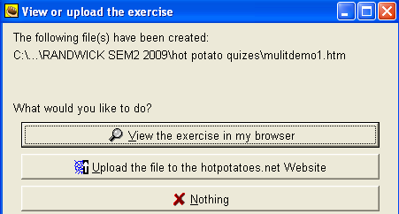
8. Return to Hot Potatoes and experiment with enhancing your questions by adding pictures and media objects (audio files) to your questions.
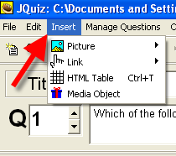
9. Save, view and test your quiz enhancements.
10. Experiment with the other Hot Potato options:
JMix, JCloze, JMatch, JCross

