A Step-by-Step Guide to getting started with Hot Potatoes
Hot Potatoes Software: http://web.uvic.ca/hrd/hotpot/
Andrew Balaam

Objectives: To put together a short cycle of exercises linked together based on the topic of animals. Examples here are in French, but feel free to choose your own language!

Instructions

Before you begin work you will need to create a Folder called Animals into which you can save your work. When creating a cycle of Hot Potatoes exercises it is important that all exercises and any associated pictures, sounds or videos making up a unit are contained in one folder. I suggest that the folder should be on the hard drive of your computer. Into the folder that you’ve called Animals, copy the pictures and sounds from the Animals folder on the Toolkit CD. You are now ready to start work.

The Hot Potatoes Front Page:

Create a match-up exercise
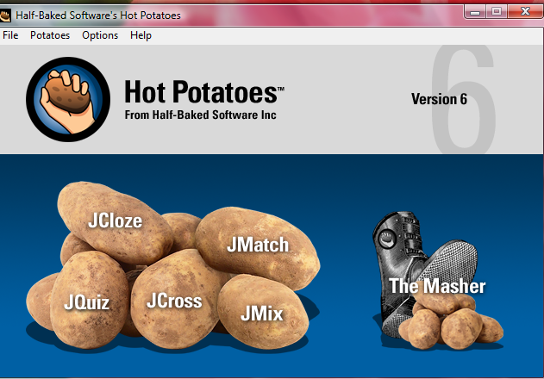
Create a gap-fill exercise

Create a short-answer or multi-choice Quiz

Create a jumbled-sentence exercise
Create an interactive crossword

- Creating a drag and drop Match-up Exercise with pictures and target language words.

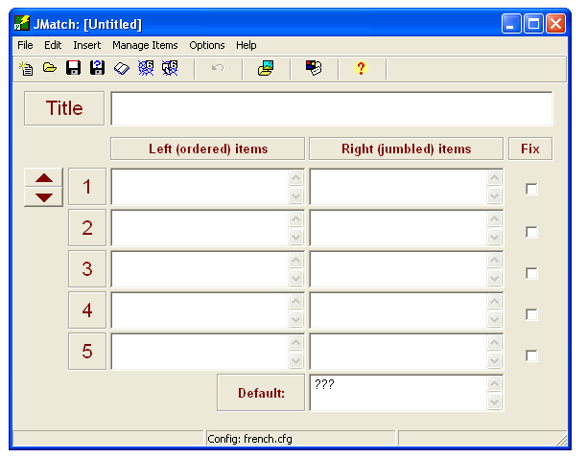
From the Hot Potatoes front page open the JMatch application by double clicking the icon. The screen will look like this:
2. Save using the red disk icon.
1. Insert the title of your page here, e.g. Animaux

1. First, insert the title of your first exercise into the title box. Next, you need to SAVE your first exercise into your Animals folder. To do this click the red disk icon indicated above, and then save this first exercise as Animals1. It is helpful for you to call all exercises in a series by the same name with a different number at the end.
Locate the Animals folder
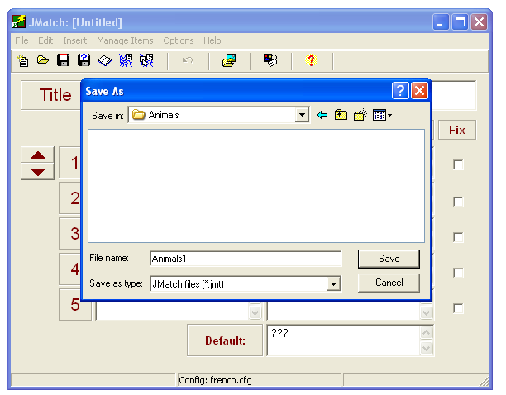

Enter the filename Animals1

Now you are ready to create the exercise. We want to have animal pictures on the left of the screen, and the target language words jumbled on the right.
- Place the cursor in the left hand box next to number 1. From the menu bar at the top of the JMatch screen, select Insert, then Picture, then Picture from local file, as shown below.
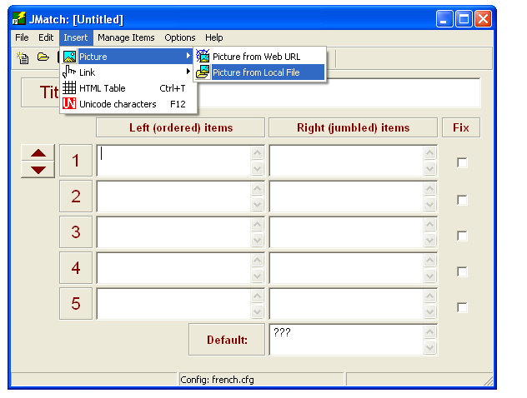

Since you have already saved your exercise in the correct folder, the Hot Potatoes programme should automatically look in the same folder for any pictures. You should therefore see the picture files you saved into the folder earlier. If not you will need to find the Animals folder on your hard disk.

Select the file you wish to have as your first picture. You will then be able to preview the picture and change its size if you wish to.
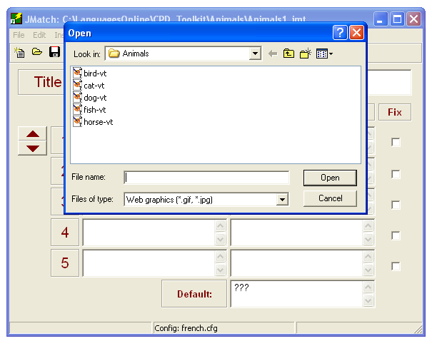

Click the file to select it.
Click Open to view it.

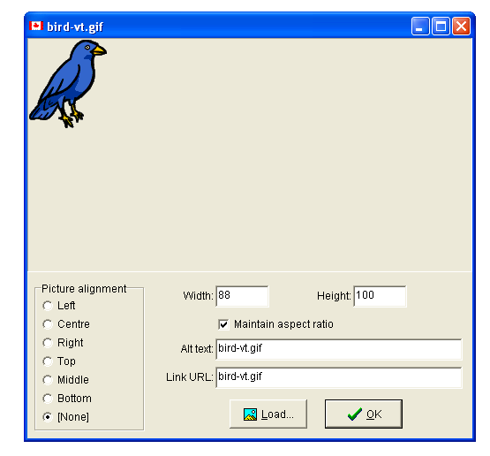
Use this if you wish to make the picture bigger or smaller. Practice will teach you how big to make pictures. In this case, decrease the 100 (height here) to 75. If the “Maintain Aspect ratio” box is ticked, the picture will simply get smaller, with the same ratios. For this exercise, decrease the 100 value to 75 each time (height or width), so that all the pictures are a little smaller and the same size as each other.
Where on the screen do you want the picture? For this exercise you can leave this section blank.

Link URL: In this box you should simply see the name of the picture file. This tells the computer to look for the picture called bird-vt.gif in the same folder as the exercise, and insert it into the exercise. If there is anything before the filename, such as the name of the folder (e.g. animals/bird-vt.gif), delete the extra bit!
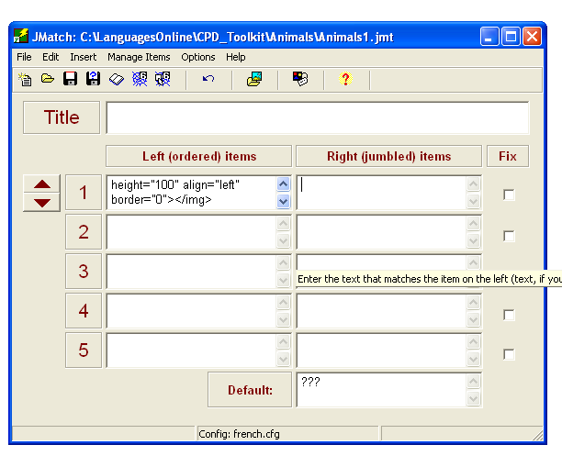
Once you are happy with the picture, click OK. You will now see what is called “html code” in the JMatch box. This tells the computer what to do, so don’t worry! You won’t see the picture of the animal until you create the exercise page later. Now insert the target language word into the box on the right. This is what the pupil will have to match to the picture.
HTML Code
Insert the target language word here, eg un oiseau

3. Repeat step 2 above for the other 4 animals in this first exercise.

4. The next important stage is to configure the exercise, deciding how it will look to the pupil. Click the Configuration button shown in the image below.
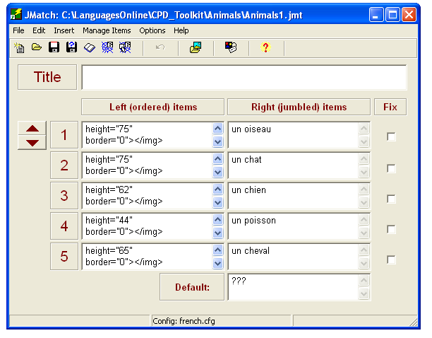
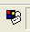
There are several parts to the configuration section. Follow each of the instructions on the next pages to complete them. Work through each “tab”, and then press OK at the END.

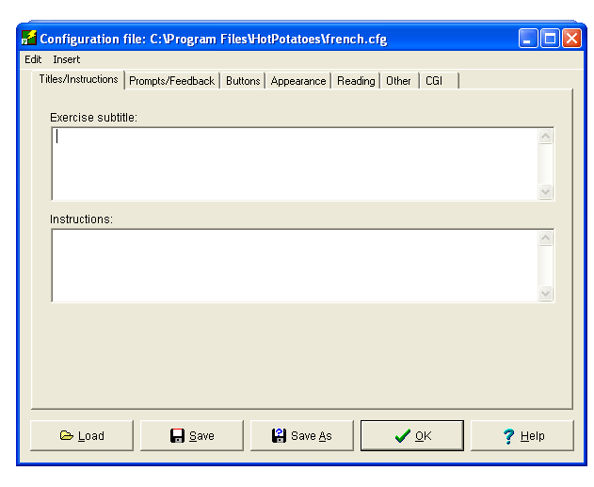
Titles / Instructions
Enter a subtitle here if you want one.
Insert your instructions to the pupil here, e.g. Trouve les paires!

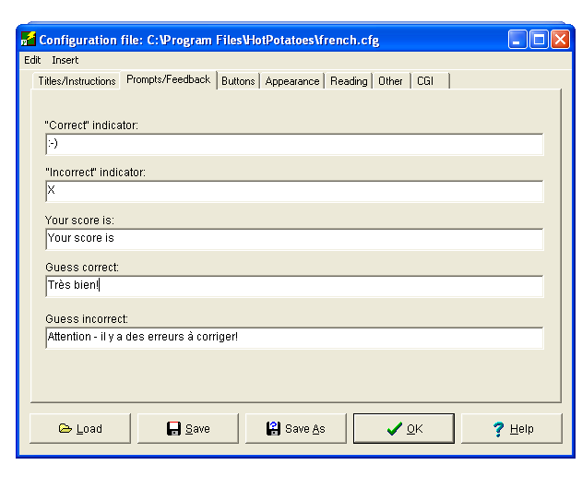
Prompts / Feedback

Insert here what you want the pupil to read when the exercise is correctly completed.
Insert here what you want the pupil to read if there are mistakes when the exercise is checked.

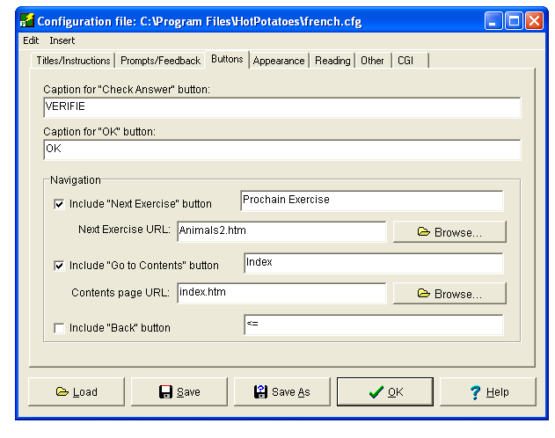
Buttons
Insert here the wording for the “Check Answer” button (target language?)

Insert here the wording for the Next Exercise button (target language?). The pupil will need to click this to move on when finished.

Next Exercise URL: This bit is important. It tells the computer the name of the next exercise in the cycle. You’ll need to decide what this is going to be at this point. For this cycle it will be Animals2.htm The “.htm” must be added each time to the file name. It tells the computer to look for a .htm file, which is the Internet format the exercises are saved in, as opposed to a Word file (.doc) or a PowerPoint file (.ppt), for example.
Index: It is useful to have an index page for each unit. It is easiest to call this Index.htm for each unit. Fill in the boxes as shown here each time, and we’ll create an Index page later, once we’ve finished the cycle.
The Back Button does what it suggests – allows the pupil to go back to the last exercise. Check the box if you want this to be possible. It doesn’t always work perfectly, so I usually leave it out.

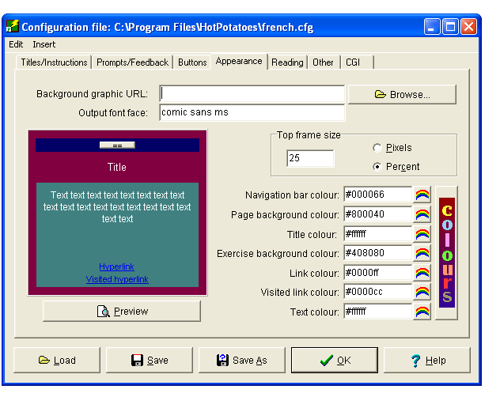
This page allows you to change the colours of the different parts of the page. By clicking each “rainbow” you can select a colour. This will appear in the preview section on the left so you can see what it looks like straight away. Alter the appearance of the page to suit your preferences.
Appearance

The remaining three “tabs” do not apply to this exercise so you can ignore them. Click “OK” to complete your configuration.

5. You are now ready to create your first exercise. You now need to SAVE the exercise twice. The first save will save the JMatch file with all the information you’ve entered. You will need this in case you want to make any alterations later. The second save will create and save the web page that the pupil will see and use.
Click the red disk again to save the JMatch File. Doing this will automatically save the file.
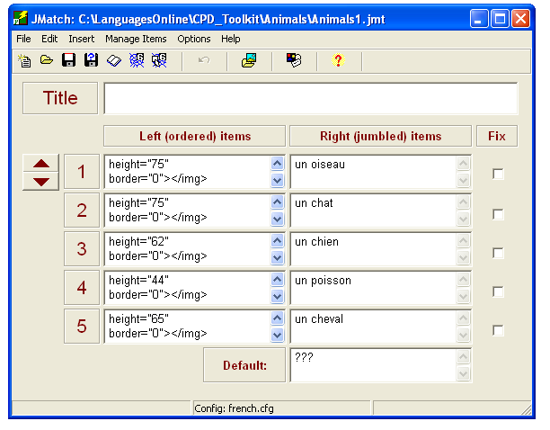

Now save the web page. There are two ways to do this using the “spider’s web” buttons. (Ignore any spider’s webs with 5 on them – use 6 only) The right hand one will create a drag and drop exercise; the left hand one will create an exercise with a drop down menu to select the answer from. Click the right hand button for this exercise.

Check that the file is being saved into your Animals folder
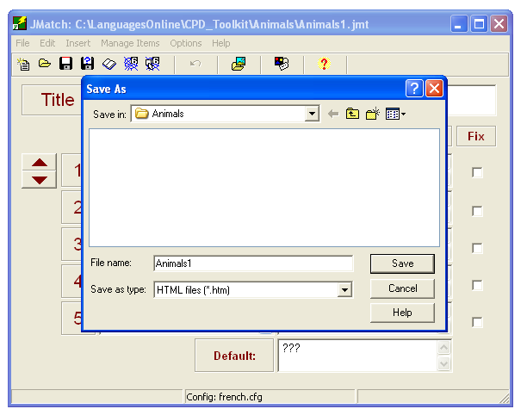

Enter the name of the file. This should be the SAME as the JMatch “creation” file, i.e. Animals1. This is important as if you need to edit a file at a later date, it is easier to find the creation file if it has the same name as the exercise file.

Now click Save.

Hot Potatoes will tell you that it has created the file. Tell it OK, then select “View the exercise in my browser” to see your exercise.

Hopefully it should look something like this:
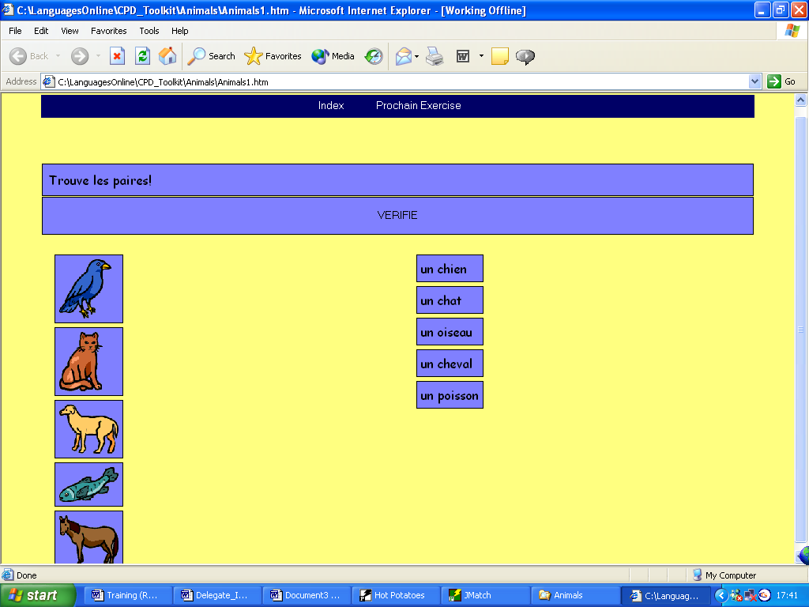

So now you’ve created your very first interactive exercise using the Hot Potatoes Programme. The process may have seemed quite long, but the good news is that you have now covered most of the basics needed across all the “Potatoes”.

You can go back into the JMatch screen to make any amendments if you need to. For example if the pictures are too big, delete the html code where you inserted it in the box and re-insert the picture, changing the size. Should you spot a smelling pistake you can simply amend it, and then resave the page – Jmatch file first, then web page.

The left hand “spider’s web”, mentioned above, will create the same exercise but looking like this:

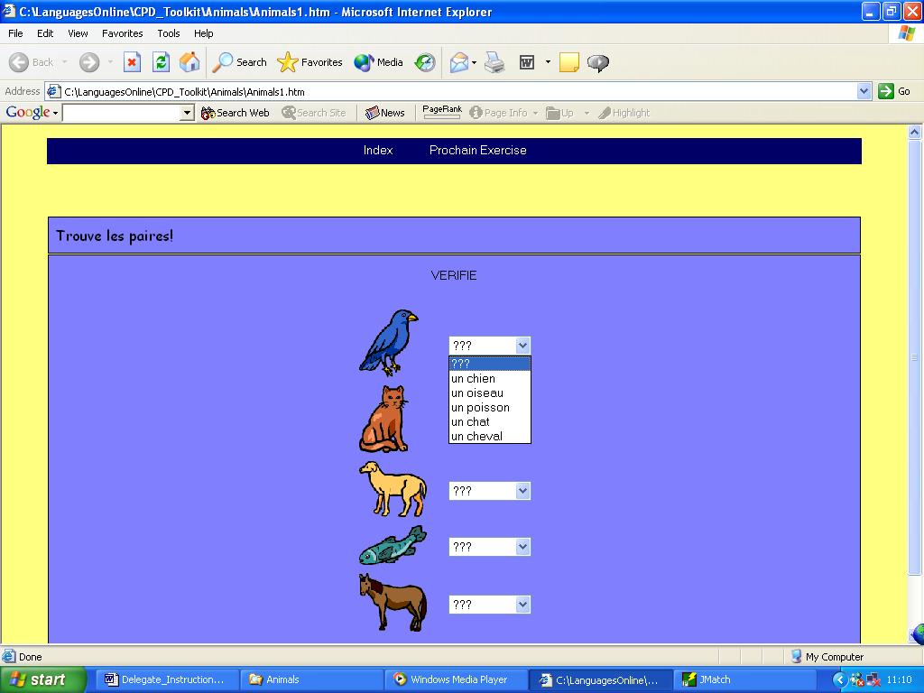

This can be useful if you have too many pictures to fit on one drag and drop page. It also has many other useful applications in different languages exercises. It’s all about imagination – how can you use the application to suit your task.
Our web site - www.languagesonline.org.uk has all sorts of exercises using all the Hot Potatoes applications.

B. Creating a Multi-choice exercise using JBC

Now let’s move on to exercise two in our cycle. This is going to be a multi-choice exercise where the pupil will have to identify and click the correct word from a list of four to identify the animal in the picture.
From the Hot Potatoes Front Page, click the JBC Potato.
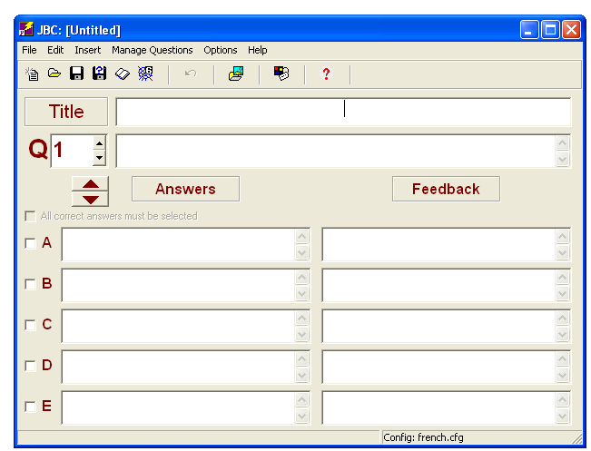
Firstly, type in the title of your exercise, e.g. Qu’est-ce que c’est?
Next, save your JBC file using the red disk. This exercise will be called Animals2, and should be saved in the Animals folder too. When you open the Animals folder you will not see any files as it is only showing JBC files, of which there are, as yet, none.

You are now ready to input the exercise.
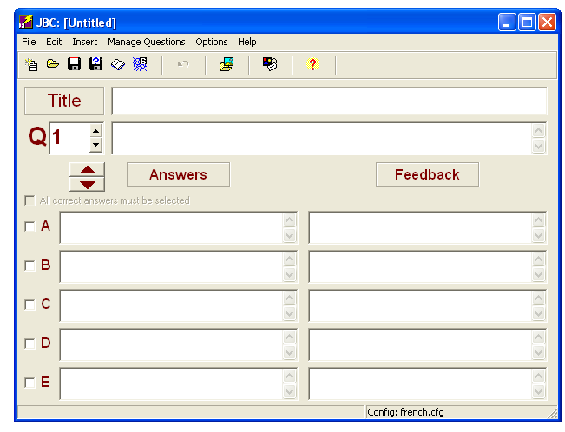
This is the “question field” where you input the question. You’re going to use a picture here though. Place the cursor in this box, then insert a picture, in the same way as before, either using Insert / Picture / Picture from local file, or using the “Insert Picture from local file” button.

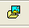
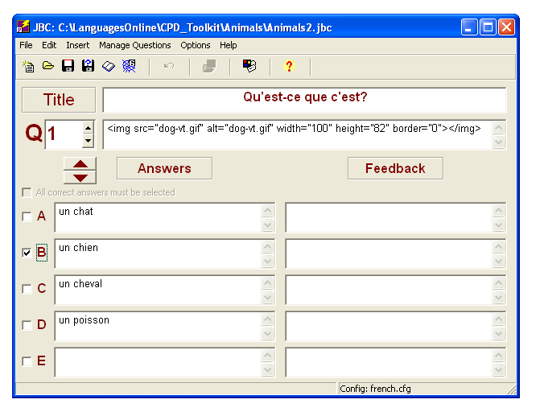

Next input the four possible answers, one right, three wrong.

You need to tell the computer which is the correct answer by ticking the box next to the correct one.

Enter as many pictures and sets of possible answers as you wish by working through the questions.

Once you’ve entered the exercise, you need to configure it, in the same way as before. Check back to section 4 above if you need a reminder of how to do this. The screens to work through are essentially the same as in JMatch. Don’t forget that the next exercise in your cycle will be called Animals3.htm. The one extra screen you need to look at is the “Other” tab:

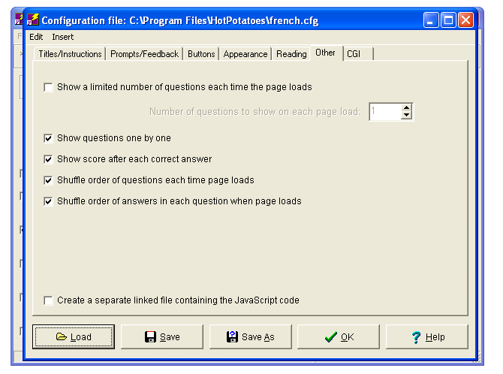
This is fairly obvious. Tick the boxes you want to be active in your page.

Now you are ready to save the second exercise in your cycle.
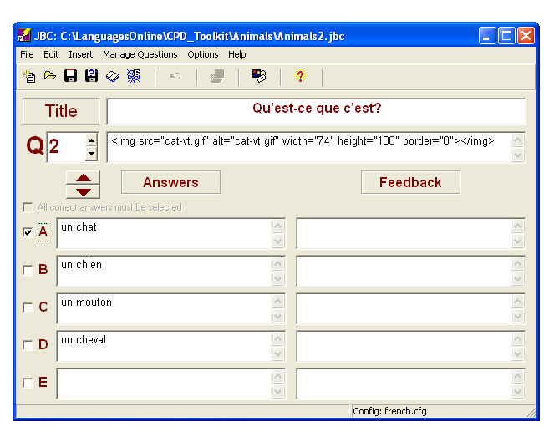

As before, you need to do two saves – the JBC file, plus the web page file. (Make sure you click the Version 6 spider’s web!) This exercise is called Animals2

Once you’ve saved it you can view it. It should look something like this:
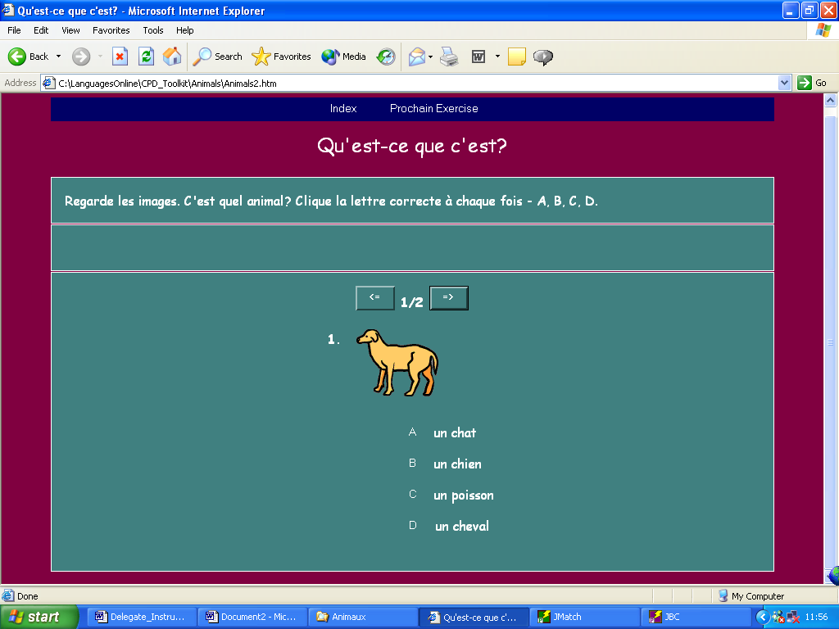

It is a good idea at this point to open up Exercise 1 in the cycle and check that by clicking the “Next Exercise” button, you do actually move onto the next exercise. If not, check that you have correctly written the name of the Next Exercise file, with .htm in the box in the buttons configuration screen.

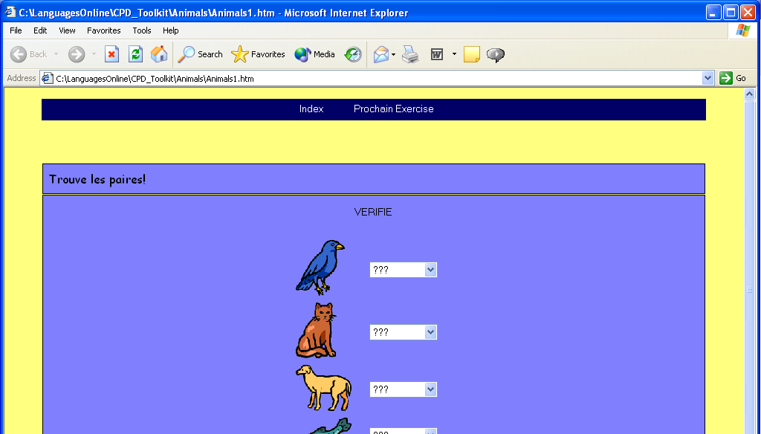
Next Exercise button

C. Creating a Re-ordering exercise using JMix

Next, let’s have a look at the JMix potato. This allows us to create jumbled sentences, where the pupil has to put the parts of the sentence back into the correct order. Keeping it simple and remaining with your animals, you can use this potato to produce an exercise where the pupil has to put 5 animals into alphabetical order.

From the Hot Potatoes front page, open the JMix potato.
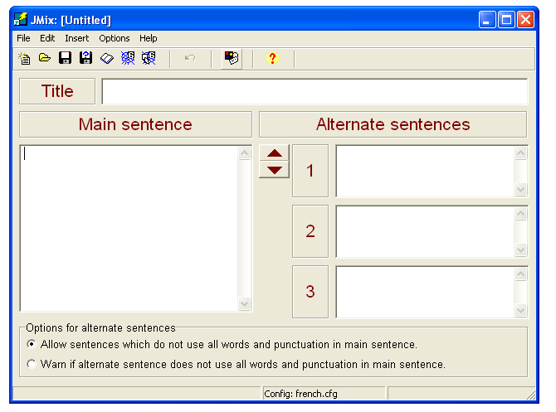
Firstly, type in the title of your exercise, e.g. Cinq Animaux
Next, save your JMix file using the red disk. This exercise will be called Animals3, and should be saved in the Animals folder too. When you open the Animals folder you will not see any files as it is only showing JMix files, of which there are, as yet, none.

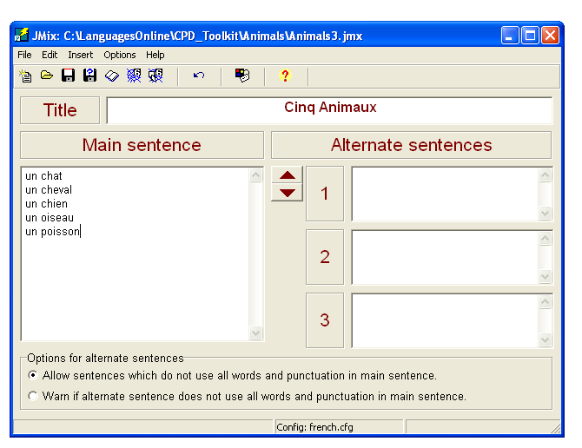
In the main Sentence box, type the list of animals in the correct order, each one separated by a line.

In the alternate sentence section you can type any other possibilities, i.e. different possible word order for a sentence. . There are none in this case, so ignore this section.

The next stage is the configuration. The screens are the same as before. Don’t forget that the Next Exercise will be called Animals4.htm. The only exception is shown below:
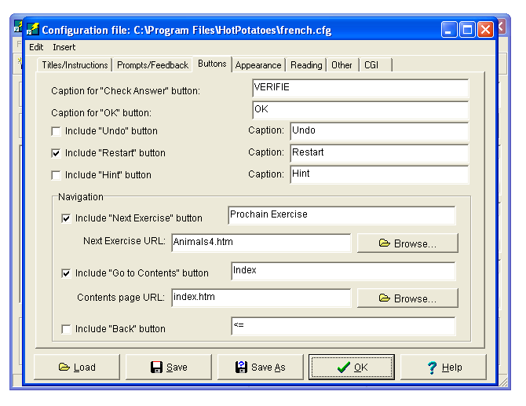
The Restart button allows the pupil to restart if he /she goes wrong. You might want to include it, you might not.

Once completed you are ready to save both the JMix file and the Web page in the normal way.

There are two spider’s webs again. (Ignore any with a 5 on them) The right hand one will create a drag and drop, the left hand one a “click the word” style exercise.

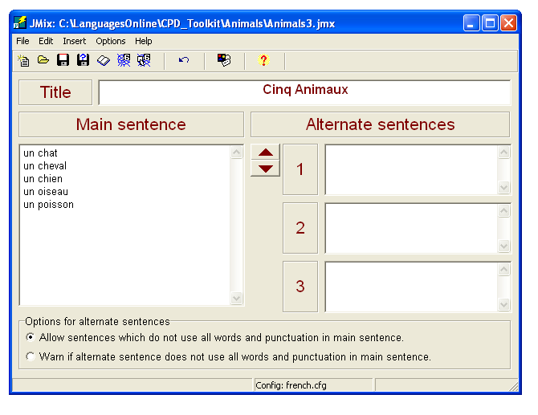

The completed exercise is shown below, drag and drop on the left, “click the word” on the right.
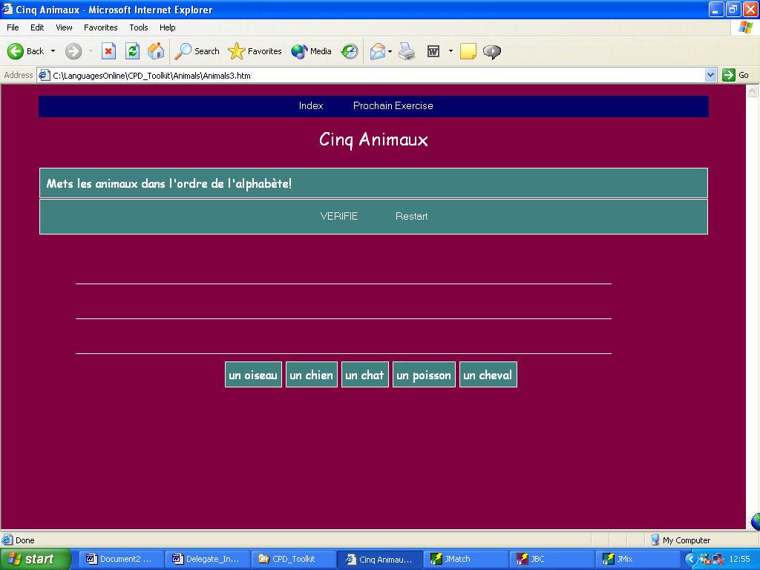
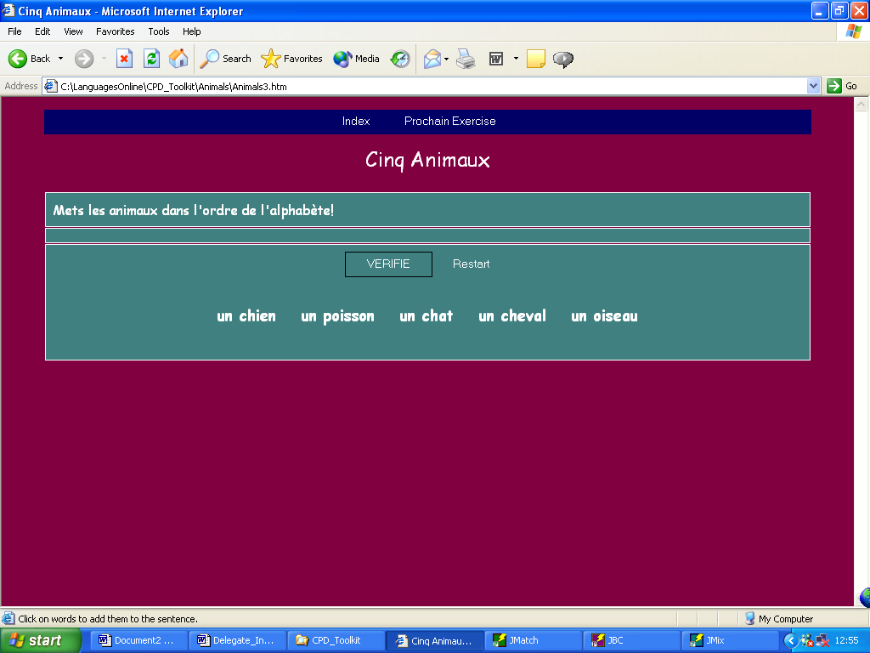

D. Creating a short answer quiz using JQuiz

Three Potatoes down, three to go!
The next exercise in the cycle is going to be a short answer quiz, where the pupil will see a picture of an animal and will be required to write the word in a box.
From the Hot Potatoes front page, open the JQuiz Potato.

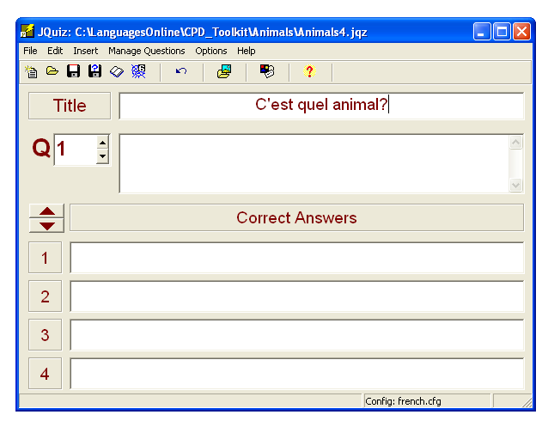

Firstly, type in the title of your exercise, e.g. C’est quel animal?
Next, save your JQuiz file using the red disk. This exercise will be called Animals4, and should be saved in the Animals folder too. When you open the Animals folder you will not see any files as it is only showing JQuiz files, of which there are as yet none.

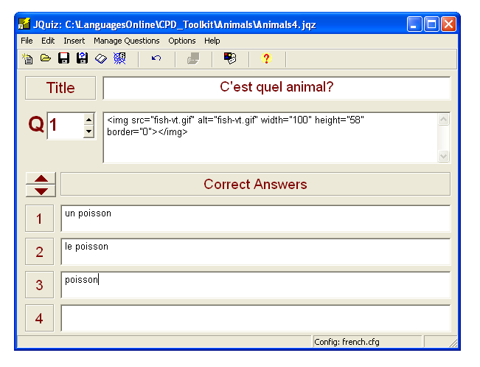

In the usual way, insert a Picture into the question field.
Next, insert the correct answer and any other possibilities. It is important to cover all possibilities so that the pupil is not told by the computer that something is wrong, when it is in fact right. Thus un poisson, le poisson and perhaps just poisson will all be acceptable here.

As with JBC, insert more pictures and answers by scrolling through.

Next you’ll need to configure the exercise in the usual way, checking also the “Other” tab, as with the JBC earlier. The next exercise will be called Animals5.htm.

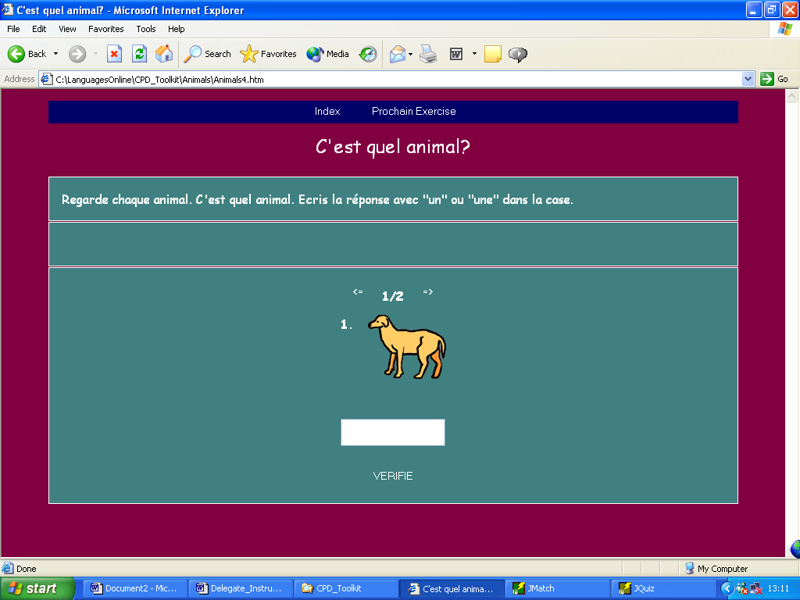
Once you are complete, save the exercise as Animals4.htm and it should look something like this:

E. Creating a gap fill exercise using JCloze

The next exercise in the cycle is going to be a gap fill exercise where the pupil will be required to type the animal word into a gap in a sentence.
From the Hot Potatoes front page open the JCloze potato.
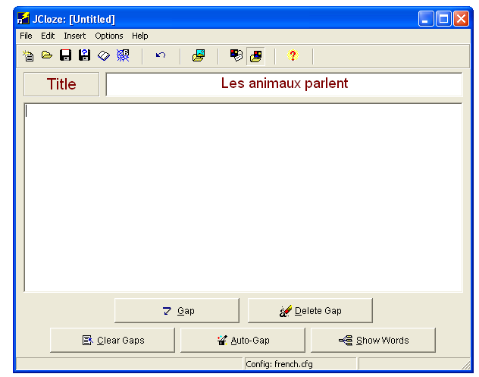

Next, save your JCloze file using the red disk. This exercise will be called Animals5, and should be saved in the Animals folder too. When you open the Animals folder you will not see any files as it is only showing JCloze files, of which there are, as yet, none.
Firstly, type in the title of your exercise, e.g. Les animaux parlent.

In the main box, type in your text, or cut and paste it from another application. Choose the words you want the pupil to have to insert and highlight it. Click the gap button at the bottom of the screen.
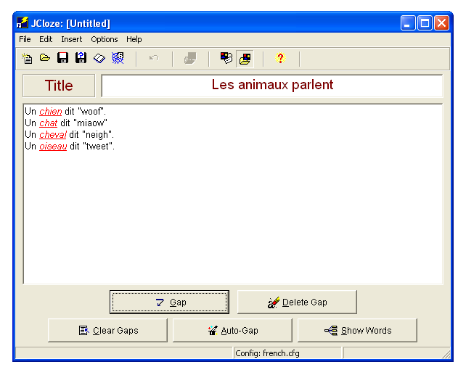

You might like to visit this website which gives you the animal sounds in different languages to make the task a little more interesting:

www.georgetown.edu/faculty/ballc/animals/

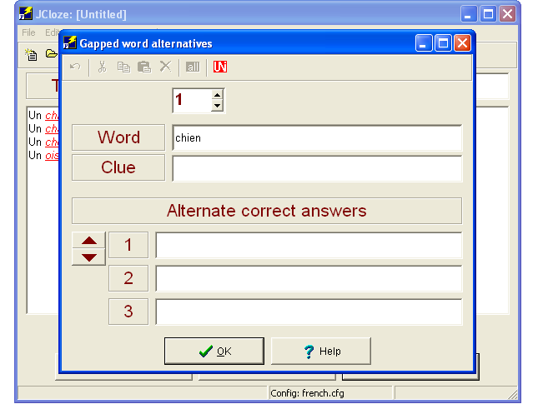

You can insert a clue if you wish to. Probably not necessary here.

You can also insert alternatives, if appropriate, if more than one word will fit in the gap. Perhaps “chienne” would be another possible word in my example here, although in reality the pupil probably won’t know that word!

Configuration time again. The next and final exercise will be called Animals6.htm. The main exception to the screens is shown below:

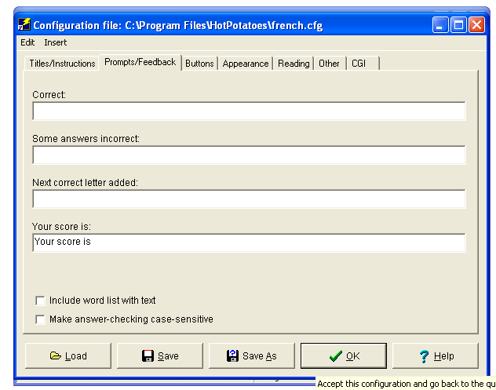
These two boxes tick boxes are fairly obvious. If you want to give the pupil a list of the words to be inserted to make the task easier, or because you are creating a text reconstruction task, tick the top box. For case sensitive checking, tick the bottom box.

To make the page a bit brighter, we can insert a picture. Alternatively if you want to include a pictorial clue, you can add a picture at the beginning of each line. Place the cursor at the beginning of the first line of the text. Now insert a picture in the usual way.
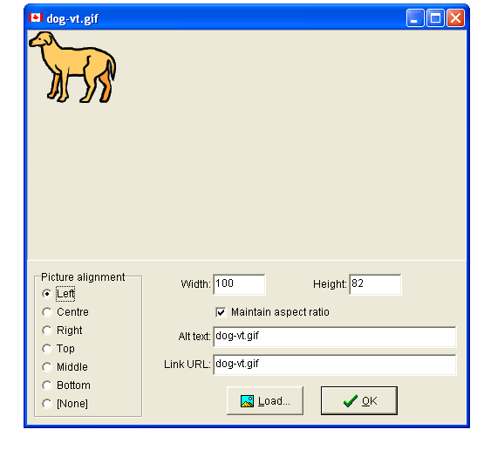

This time this section becomes relevant. It tells the computer where on the page to put the picture. Use either Left or Right.

Now you can save the exercise in the usual way, remembering to save twice.

The finished product should look something like this:

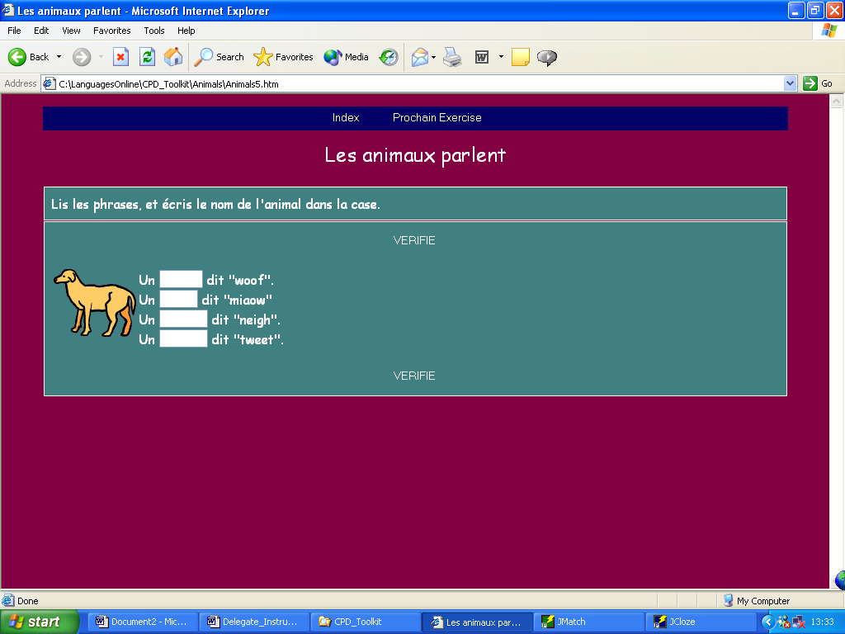

F. Creating an Interactive Crossword using JCross

And now for the final exercise in this cycle. Let’s create an interactive crossword to practise the words we’ve used in the cycle.
From the Hot Potatoes front page, open the JCross potato. This is a wonderful feature that allows you to produce a crossword in a matter of minutes, and also gives you the opportunity to produce a printable version too!
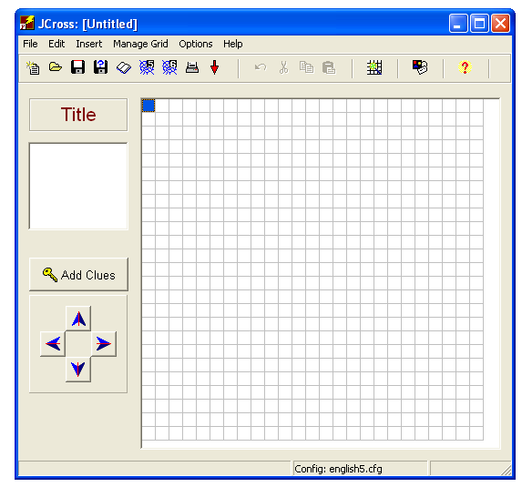

Click the Insert words button to enter the words for the crossword.

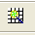

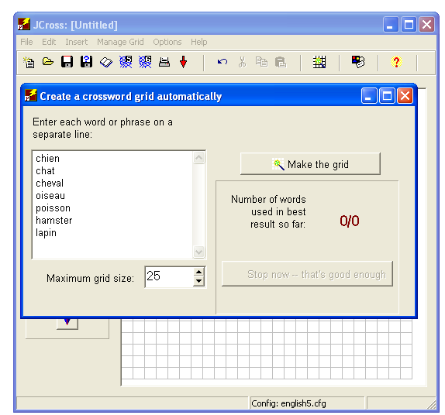

Enter a list of the words here, one per line, checking spelling very carefully!

Decide how big you want the grid to be. The smaller the grid, the harder it will be to get a lot of words in.

Once finished, click “Make the Grid”

The programme will now attempt to fit as many words into the grid as possible.

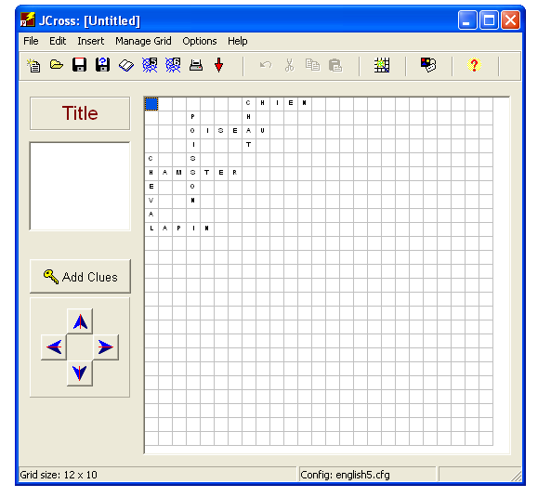

Enter the Title of the crossword here
E.g. Les Animaux

Now it is time to add the clues. Click the button.

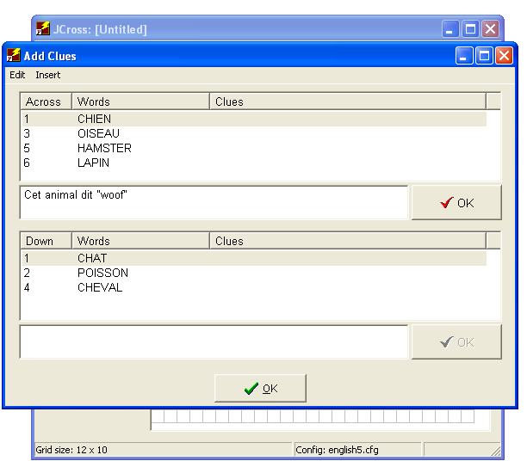
Select a word, and then enter the clue for that word in the box at the bottom of the section. Then click “OK”. Repeat for all the words.

Next, you need to configure you exercise in the usual way. Since this is the last in our cycle, it is a good idea to link it back to the first one to create a full cycle. To do this, in the next exercise link section on the buttons page, write Animals1.htm.

Finally, save your exercise, remembering to save the JCross file and the web page.
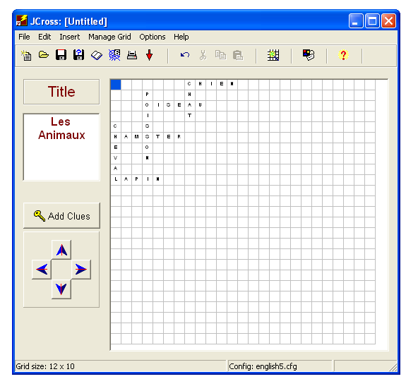

The printer button creates a page that you can print to create a worksheet.

The spider’s web creates the interactive web page.

The finished page should look like this:
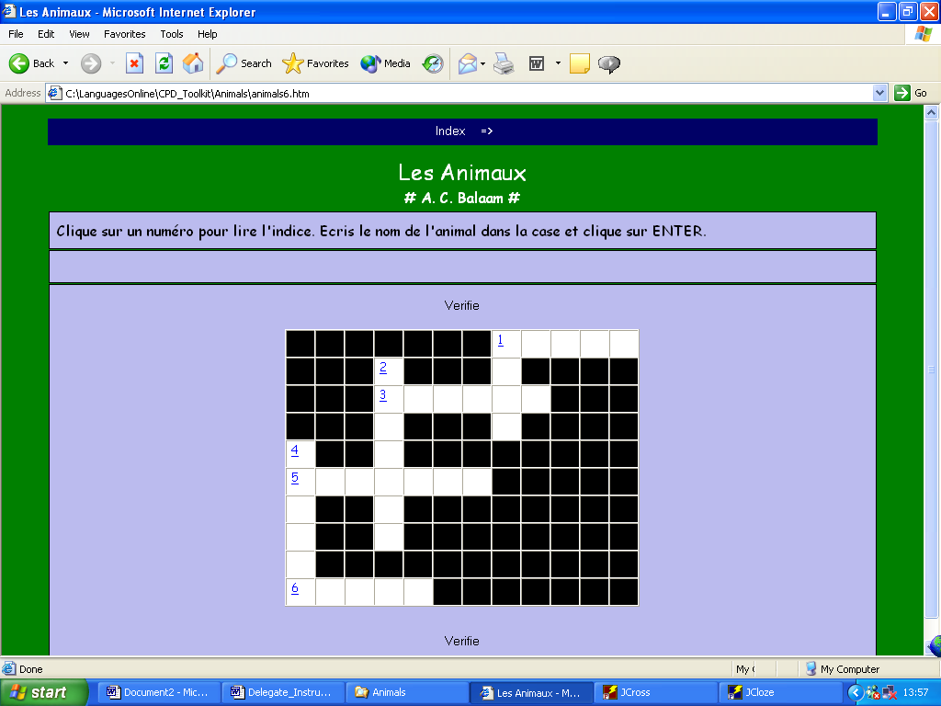

And there you have a cycle of six exercises. Hopefully, by clicking the Next Exercise button you should be able to go through all six.
I have only demonstrated very simple versions of what can be done with each Hot Potato application. The programme has so much more potential, and in my experience is limited only by the imagination and creativity of the user. Practice and experimentation are the best ways to find out just what you can do.

G. Creating a Unit Index Page

I find that it is useful to include an Index page with each unit that I write. If a pupil does not finish a cycle in one session they can easily begin where they left off next time. It also allows users to see what is in a cycle.
Microsoft Word can be used to create an online index page, in the absence of a more powerful web editor, such as FrontPage or Dreamweaver for example.
The idea of an Index page is to have one page with links to all the exercises so that any can be accessed – just like the index at the beginning or end of a book tells you which page to go to for what you are looking for.

In Word, create a list of the exercises in your cycle:
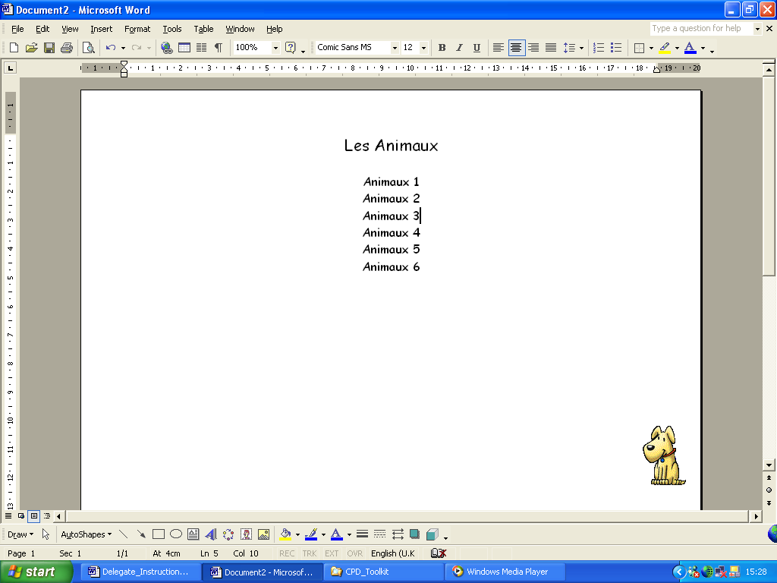

Now save the file into your Animals folder:
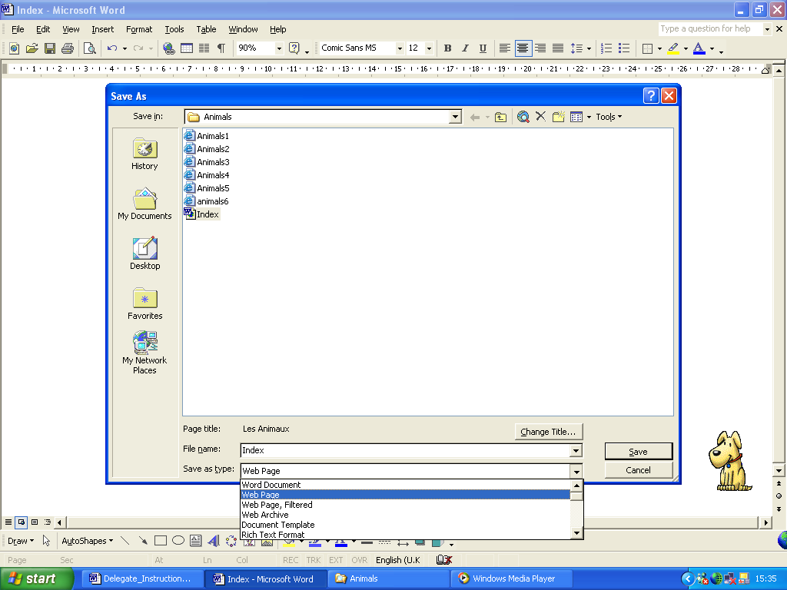

The filename will be Index as that is what you have called it in each of the Hot Potato exercises you’ve already created.

You need to ensure that you are saving the file as a web page and NOT as a word document. Next to Save as Type, select Web Page or .htm file.

Click Save to create the file.

Now you need to create the hyperlinks which will make your index page work.

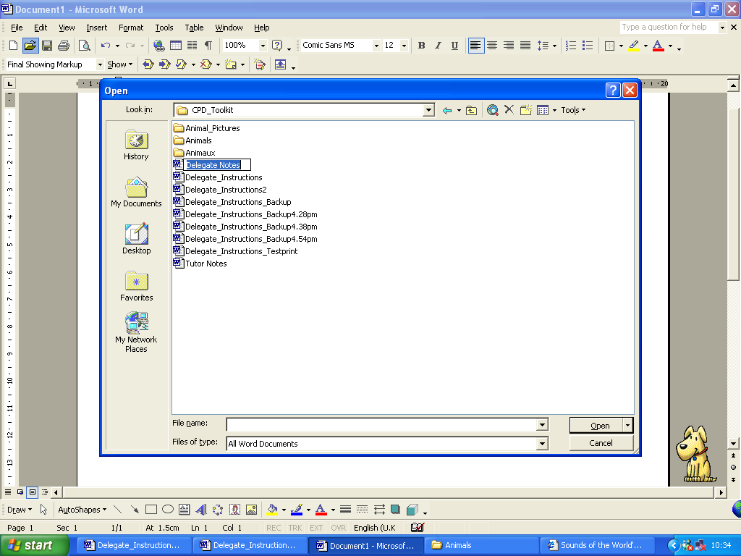
Back on the page, highlight the first exercise name. (Animals1) If your Insert Hyperlink dialogue box does not show the animals folder, you will need to locate it on your hard drive. Use this button.

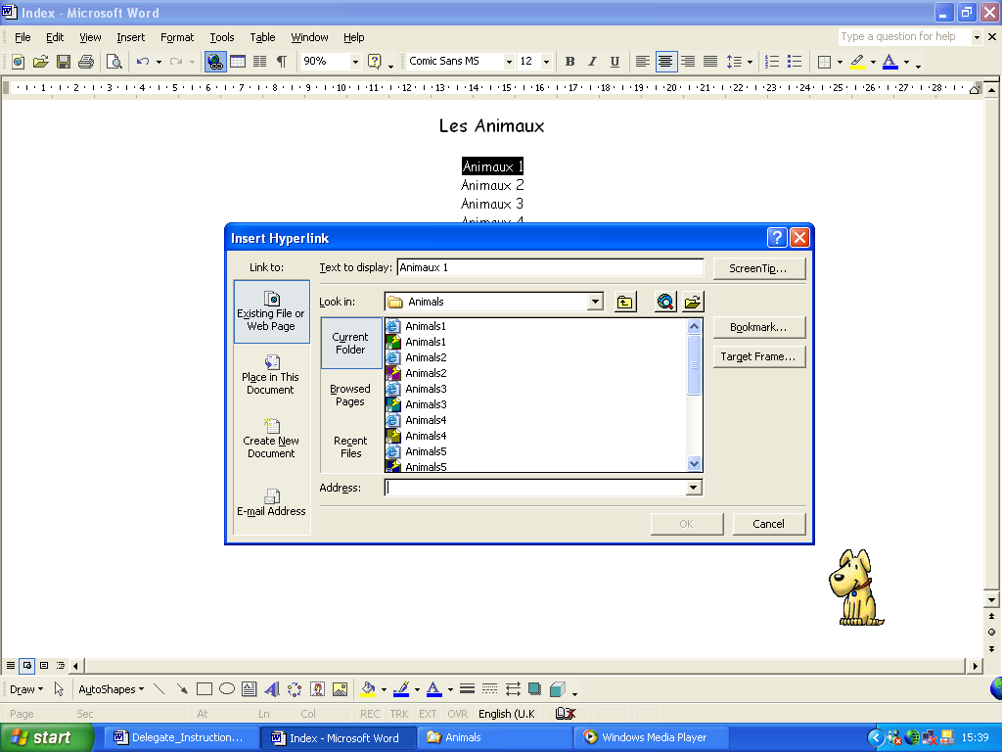
Highlight the text.

Click the Hyperlink button

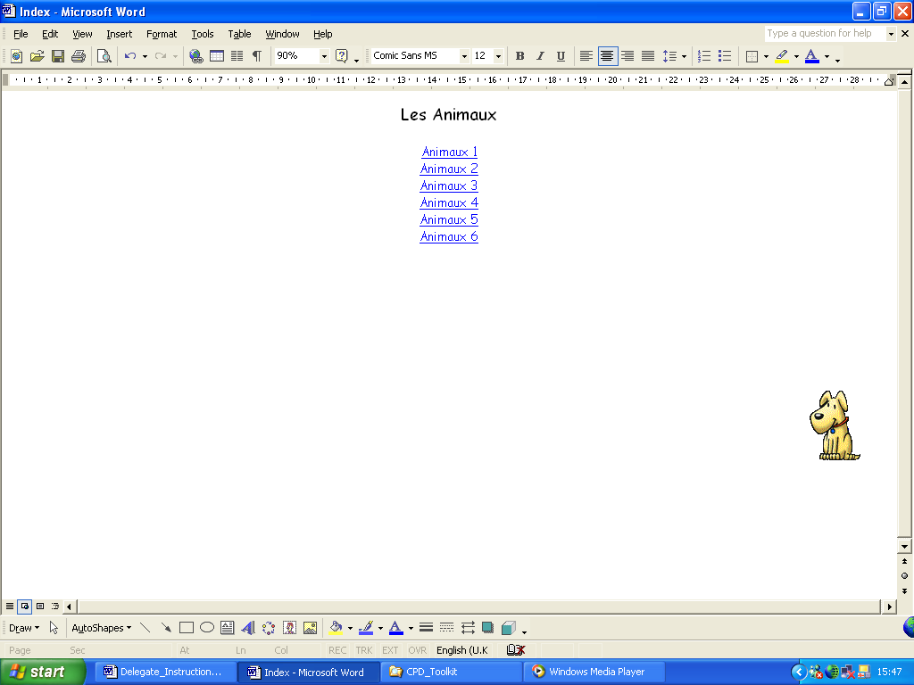
Word should automatically look in the Animals folder, since that is where the Index file is saved too.

From the list select Animals1. You’ll notice that there are 2 Animals1 – one is a web page and one is your JMatch file. Make sure you select the right one! (the one with the “e” logo.)

Once selected, the filename should appear here: It should say Animals1.htm
Click OK to create the hyperlink.

When you return to the word page, you should find that the text you selected has changes to blue and is now underlined. This indicates that it is a hyperlink. Repeat the above with the other 5 links.

Now re-save your page. If you now have a look at one of your Animals exercises, you should find that by clicking the Index button at the top of the screen, you can view the index and jump straight to another exercise, and navigate around your unit.
If you wish to make your index page look more interesting you can do all sorts of things to it, such as change the background colour:
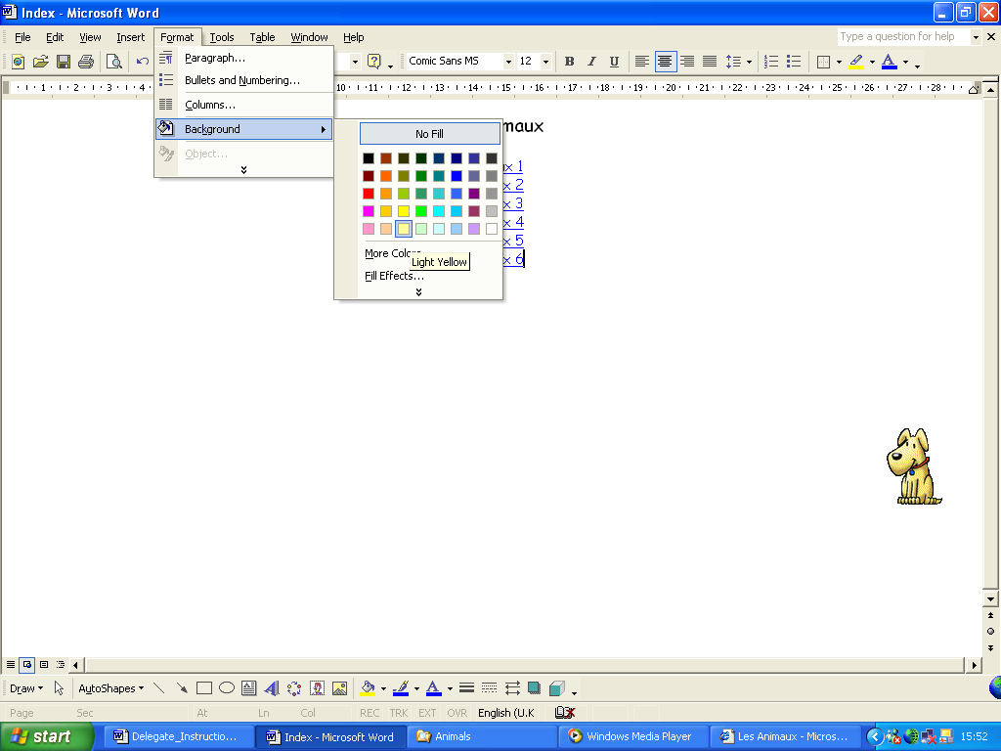

Click Format.

Click Background.

Select a colour.

And there you have it – I hope!

The Hot Potatoes programme is really not complicated. It does require the understanding of a few basic principles and ideas, but once you’ve got them, you are free to use the programme to create all manner of exercises with unending variety and diversity. It’s all about experimenting and playing around to see what you can create, or how you can achieve what you have in your mind’s eye.
For more ideas, please visit our website – www.languagesonline.org.uk to see how we use the Hot Potatoes Programme. There is very little on the entire website that has not been created using one of the six programmes outlined above.

I hope you’ll feel inspired to have a go at using the Hot Potatoes programme with your own pupils. I really do believe, based on our experience, that the effort put in is well worth it.
Good luck!

Andrew Balaam

