Mail Merge Tutorial Using MSWORD

**1. Create a table with contact details for your business network. For example:**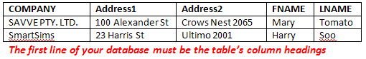

**2. Write the letter to be sent to members of your business network. For example:***Your Company Name  
Your Company Address****INSERT CONTACT’S NAME HERE  
INSERT CONTACT’S ADDRESS HERE*** *November 24, 2010*

*Dear* ***INSERT CONTACT’S FIRST NAME HERE***

*The first paragraph of a typical business letter is used to state the main point of the letter.*

*The second paragraph, states the supporting details to justify your purpose.*

*The closing paragraph, briefly restates your purpose and why it is important.*

*Yours faithfully*

*Kevin Rudd  
Digital Media Student*

**3. Select MAILINGS then START MAIL MERGE then LETTERS**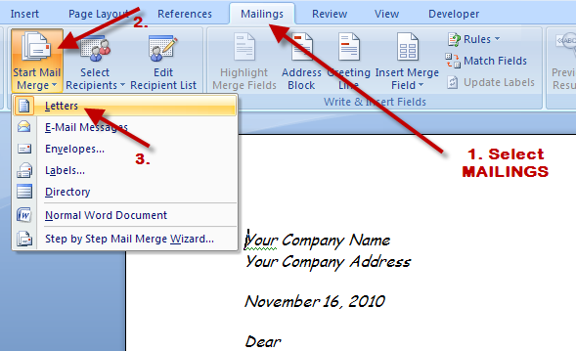

**4. Click SELECT RECIPIENTS then select USE EXISTING LIST and browse to and open your MSWORD TABLE DOCUMENT**

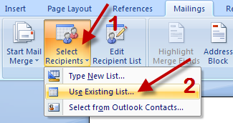

**5. Select EDIT RECIPIENT LIST and deselect contacts NOT receiving letters**

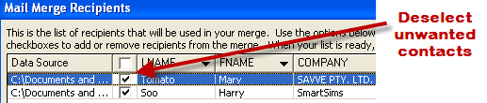

**6. Place cursor at the position for inserting a field. Select INSERT MERGE FIELD. 3. Select the field to be inserted 4. Click INSERT then click CLOSE. Repeat for all fields in your letter.**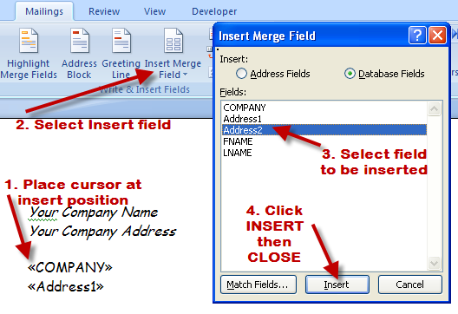

7**. Select PREVIEW RESULTS and click to view merged letters. Select FINISH AND MERGE and then select EDIT INDIVIDUAL DOCUMENTS to send all merged letters to a document. Edit – save merged letters and print**.  
