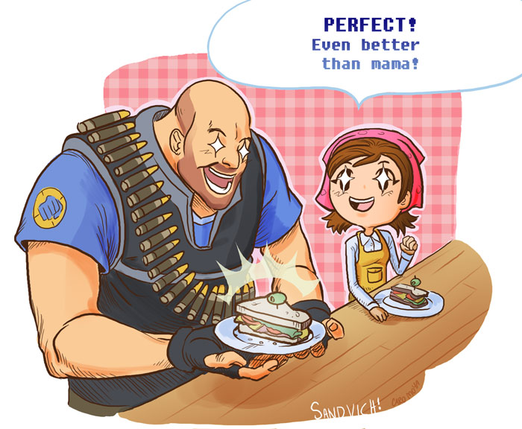
Name: _______________________ Pd: ______

Basic Stoichiometry PhET Lab
Let's make some sandviches!
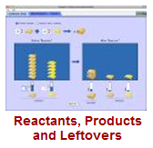
Introduction:
When we bake/cook something, we use a specific amount of each ingredient. Imagine if you made a batch of cookies and used way too many eggs, or not enough sugar. YUCK! In chemistry, reactions proceed with very specific recipes. The study of these recipes is stoichiometry. When the reactants are present in the correct amounts, the reaction will produce products. What happens if there are more or less of some of the reactants present?

Vocabulary: Before your begin, please define the following:
Limiting Reactant: ______________________________________________________________________
Excess Reactant: ______________________________________________________________________
Synthesis Reaction: ______________________________________________________________________
Combustion Reaction: ______________________________________________________________________
Mole Ratio: ______________________________________________________________________
Diatomic Molecule: ______________________________________________________________________
Mole: ______________________________________________________________________
Hydrocarbon: ______________________________________________________________________
Procedure: PhET Simulations → Play with the Sims → Chemistry → Reactants, Products, and Leftovers
If a yellow bar drops down in your browser, click on it and select "Allow Blocked Content"

Part 1: Making Sandviches:
- The is a simulation of a two-reactant synthesis reaction. In this case, one reactant will be limiting, while the other will be in excess.
- Take some time and familiarize yourself with the simulation.
- Set the reaction to a simple mole ratio of 2:1:1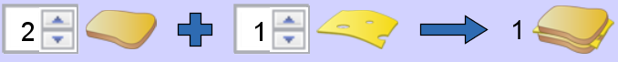
- Complete the table below while making tasty cheese sandwiches:
Bread Used | Cheese Used | Sandwiches Made | Excess Bread | Excess Cheese
5 slices | 5 slices
4 slices | 3slices
 |  | 2 sandwiches | 1 slice | 0 slices
6 slices |  | 3 sandwiches |  | 4 slices
Part 2: Real Chemical Reactions: 

- Now let's work with real chemical reaction, one that creates a very entertaining BOOM!
- What is the mole ratio for the reaction of hydrogen and oxygen to produce water?
$\text{__}H_{2}+\text{__}O_{2}→\text{__}H_{2}O$
- Complete the table below while making water H₂O from hydrogen H₂ and oxygen O₂:
Hydrogen Molecules H₂ | Oxygen Molecules O₂ | Water Molecules H₂O | Excess H₂ | Excess O₂
4 molecules | 4 molecules
7 molecules | 6 molecules
 |  | 3 molecules | 0 molecules | 0 molecules
9 moles | 8 moles
 |  | 4 moles | 1 moles | 3 moles
3.5 moles | 2.5 moles
1.5 moles |  | 1.5 moles | 0 moles | 0 moles
- Notice that the labels changed from molecules to moles. This does not change the mole ratio, as a mole is simply a large number of molecules. How many molecules is a mole? _________________

- Now try producing ammonia, a very important chemical in industry and farming.
- What is the mole ratio for the production of ammonia? $\text{__}N_{2}+\text{__}H_{2}→\text{__}{\text{NH}}_{3}$
- Complete the table below:
Moles N₂ | Moles H₂ | Moles NH₃ | Excess N₂ | Excess H₂
3 moles | 6 moles
6 moles | 4 moles
 |  | 4 moles | 2 moles | 2 moles

- Combustion of hydrocarbons like methane CH₄ produce two products, water and carbon dioxide CO₂.
- What is the mole ratio for the combustion of methane? $\text{__}{\text{CH}}_{4}+\text{__}O_{2}→\text{__}{\text{CO}}_{2}+\text{__}H_{2}O$
- Complete the table below:
mol CH₄ | mol O₂ | mol CO₂ | mol H₂O | Excess mol CH₄ | Excess mol O₂
4 mol | 4 mol
3 mol | 6 mol
 |  | 2 mol | 4 mol | 5 mol | 1 mol
 |  | 3 mol |  | 7 mol | 1 mol
- The BEST PART: Challenge other members of yourself to the .
Your First Score:_______lvl__ Your Best Score:________lvl__

Name: _______________________ Pd: ______
Basic Stoichiometry Post-Lab Homework Exercises
1. Load the "Reactants, Products, and Leftovers" simulation and work through each of the levels of the Game! At home, you can find the simulation by going to http://phet.colorado.edu/ or googling "phet." You may have to download or update the version of Java on your computer.

Complete each exercise on your own. Remember to use proper units and labels.

2. For the reaction$P_{4}+6{\text{Cl}}_{2}→4{\text{PCl}}_{3}$, determine how many moles of chlorine Cl₂ would be needed to react with 3 moles of phosphorus P₄ to entirely use up all the phosphorus. 2)________________

3. If 5 moles of P₄ reacted with 22 moles Cl₂ according to the above reaction, determine:
a) How many moles PCl₃ are produced a)________________

b) How many moles of P₄ are left in excess after the reaction (if any) b)________________

c) How many moles of Cl₂ are left in excess after the reaction (if any) c)________________

In reality, reactants don't have to react in perfect whole-numbers of moles. In a two-reactant synthesis reaction, usually one reactant gets entirely used up, even if that means using fractions of a mole of reactant. For instance, when solid, metallic aluminum Al and red, liquid bromine Br₂ are brought together, they make a white solid according to the reaction $2\text{Al}+3{\text{Br}}_{2}→2{\text{AlBr}}_{3}$. If 5 moles of aluminum Al was reacted with 10 moles bromine Br₂, all five moles of aluminum would react, with 7.5 moles bromine. (2:3 mole ratio)

4. Now assume 3 moles Al and 4 moles Br₂ react
a)Which chemical is the limiting reactant? a)________________

b)Which chemical must be the excess reactant? b)________________

c)How much (in moles) AlBr₃ gets produced? c)________________

d)If all the limiting reactant gets used up, how much of the excess reactant is left? d)________________

5. What is the maximum amount (in moles) of NaCl that can be produced from 3.4 moles of Na and 4.5 moles of Cl₂ according to the reaction $\text{__}\text{Na}+\text{__}{\text{Cl}}_{2}→\text{__}\text{NaCl}$(left for you to balance).

5)________________

