Gas Prices in America
Keep Getting Higher!
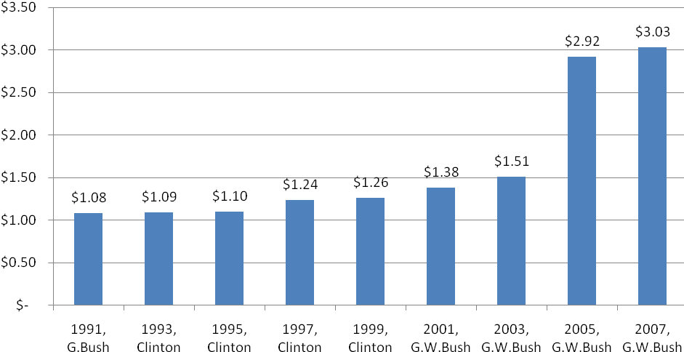
Gas prices increase every year naturally, just like the price of a gallon of milk, the cost of a new car, and most other items and services. When I was in high school, gas cost a little more than a dollar a gallon. Under President Clinton, the price of gas slowly increased from 1.09 per gallon to 1.26 per gallon. This is an increase of about 20% over eight years. Under President Bush, the price of a gallon of gas more than doubled from $1.38 per gallon in 2001 to over three dollars per gallon in 2007. Today, in 2008, a gallon of gas costs almost 4 dollars!
Some people think that George W. Bush caused the gas prices to increase while he was president, because his family owns companies that make money from gas and oil. This graph doesn’t support that idea, since the largest increase in gas prices was between 2003 and 2005, after Bush had already been president for a few years.
Another opinion is that gas prices increased because of the tragedy of September 11th, and the wars in Iraq and Afghanistan. Other people still think the rise in gas prices is Bush’s fault since he chose to go to war with Iraq and Afghanistan. Whatever you believe, this bar graph shows that the price of gas goes up every year, no matter who is president.

