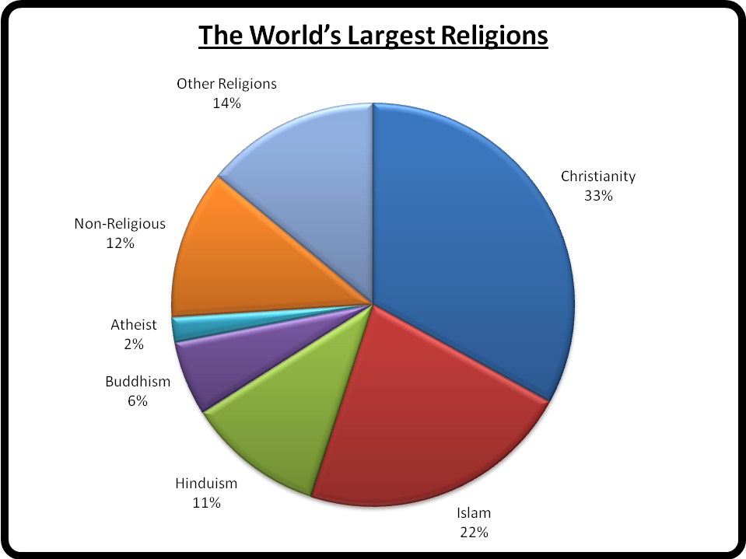

A majority of the world’s population is monotheistic, or believes in one god. The largest monotheistic religions are Christianity and Islam, and these two religions account for over half of the earth’s population. Hinduism is the world’s next largest religion, with 11% of the world’s people. Hinduism is polytheistic, which means they believe in many gods, instead of just one. Many Native American tribes are also polytheistic.
There are many different ways to be a Christian or a Muslim, and most large religions have differences within the group. Christianity is made up of many smaller sects, or religious groups, such as Protestants, Catholics, Mormons, Jehovah’s Witnesses, and Baptists. Islam also has many sects such as Sunnis, Shiites and Sufis.
This chart also shows that not everyone in the world belongs to a specific religious group. 12% of the world is non-religious. This means that more than more than one out of ten people choose not to belong to any religion. And 2% of the world’s population is atheist, meaning that they don’t believe in god.

