Finding Standard Deviation Using Technology

Using Ti-83/84 to find standard devation (from tc3.org)

Step 1: Enter the numbers in L1
By the way, this note uses list L1, but you can actually use any list you like, as long as you enter the actual list name in the command in Step 2. (It doesn’t matter whether there are numbers in any other list.)
Enter the following data points: a sample of quiz scores in a (fictitious) class were 10.5, 13.5, 8, 12, 11.3, 9, 9.5, 5, 15, 2.5, 10.5, 7, 11.5, 10, and 10.5. It’s hard to get much of a sense of the class by just staring at the numbers, but you can easily compute the common measures of center and spread by using your TI-83 or TI-84.
[STAT] [ENTER] selects the list-edit screen.
Cursor onto the label at top of first column, then [CLEAR] [ENTER] erases the list. Enter the x values.

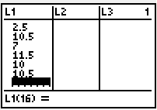

Step 2: Compute the Statistics
Select the command.
[STAT] [CALC] [ENTER] pastes the command to the home screen.
Specify which statistics list contains the data set. Show your work: write down and the list name.
Assuming you used , enter [L1].
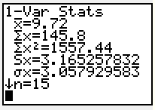

The important statistics are
- sample size n = 15 Always check this first to guard against leaving out numbers or entering numbers twice.
- mean x bar = 9.72 (Use symbol μ if this is a population mean.)
- standard deviation s = 3.17 Since this data set is a sample, use S_{x} or s for the standard deviation. When the data set is the whole population, use σ_{x} or σ for the standard deviation. If rounding is necessary, remember that we round mean and standard deviation to one decimal place more than the data.
for a video demonstration watch the youtube video below
http://www.youtube.com/watch?v=5kz16kbOTG0

