Using Ti-30 to find standard devation
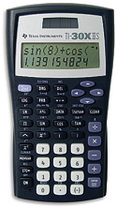
Example Data Set: 1, 1, 1, 4, 7, 7, 7 sample standard deviation = 3
Hit 2nd, Data (this means really that you are entering the STAT menu)
Select 1-Var.
A blank screen will appear. Select Data again. X₁ will appear.
Enter in 1. Scroll down, you will see FRQ=1. Scroll down.
You will see X₂=. Enter 1. Scroll down, you will see FRQ=1. Scroll Down.
Enter the last number 7. Scroll down, you will see FRQ=1.
Select STATVAR.
Use the right arrow key to get: n, x-bar, and s_{x}.

how to's for other calculators available from this website:
http://www.stat.ufl.edu/~mmeece/2023/Calculator.htm

