Technology Notes: Scatterplots on the TI83/84 Graphing Calculator
Enter the data, with explanatory variable in list 1 and the response variable in list 2. The Next, press 2ND [STAT-PLOT]to enter the STAT-PLOTS menu and choose the first plot.
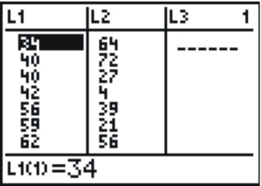
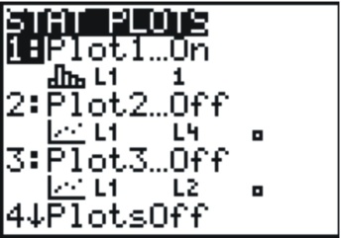
Change the settings to match the following screenshot:
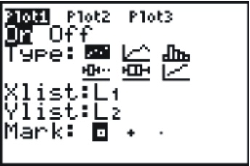
This selects a scatterplot with the explanatory variable in and the response variable in . In order to see the points better, you should choose either the square or the plus sign for the mark. Finally, set an appropriate Window to match the data. In this case, we looked at our lowest and highest percentages in each variable, and added a bit of room to create a pleasant window. Press [GRAPH] to see the result, which is shown below.
