Technology Notes: Correlation on the TI83/84 Graphing Calculator
Enter the data, with explanatory variable in list 1 and the response variable in list 2.
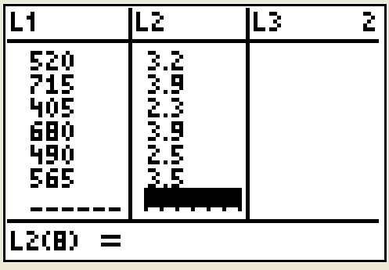
To find correlation you must first make sure the diagonostic function on your calculator is turned on. Press the [2nd] key followed by the [0] (zero) key to bring up the catalog menu. Scroll down until you find DiagnosticOn. Press the [Enter] key. Your calculator should now be ready to display correlation, and you should not need to go through the diagnostic on step again.
Now press [STAT] and move over to the [CALC] heading, and then down to option 4:[LinReg(ax+b)]. See figure below.
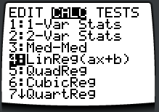
Press [ENTER] on option 4 and you should see the screen below.
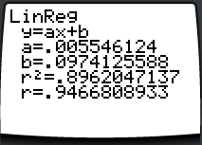
There you can see correlation is about =0.95.

