Technology Notes: Correlation on the Ti-30XIIS or NonGraphing Calculators
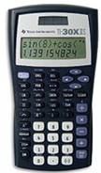
Some nongraphing calculators have the ability to find correlation as well. To do so you must first enter your data. On this model of calculator you do some by pressing the [2nd] [DATA] then select [2-VAR] and press [ENTER] , then press the [DATA] , your screen should display x₁=. Enter in your first explanatory variable and press down. Your screen will now disply y₁=. Enter the response variable that corresponds to your x₁. Press down and repeat until all data is entered. When finished press [STATVAR] and press over until displayed.

