Citing your sources
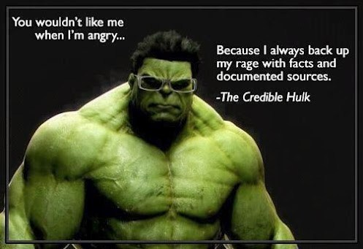
Every term, students from 7th grade all the way through college English courses, make the same type of errors over and over again. This page will help you avoid some of those mistakes.

We’ll look at the most common mistakes and how to fix them, but the number one way to avoid them is to look at an example that is cited properly and copy that! Substitute the information in the correct citation with information from your own.

Mistake #1: Adding your works cited to the end of the paper.
What you should do: The Works Cited page gets its own page! Don't just add it to the next line of your paper.

Mistake #2: Just linking to your sources.

If you just give a link to the website you used you are not citing it properly. This mistake is made more often than any of the others; this is just about the worst thing an instructor can see.
What you should do: Create an actual citation for your resource.

Mistake #3: Lack of formatting/organization.

The formatting of the citation is not correct. You may have all of the correct information in the proper order, but formatting matters and you'll want to make sure it is displayed properly.
What you should do: Look at the examples and make yours look like those. Don’t forget to alphabetize.

For Example

Fila, Jon. Indent Extra Lines When Your Cited Work Takes Up More Than One
Line. 1. Minneapolis, MN: Book Publishing Company for How Your Citations
Should Look, 2006.

Isn't good enough. Everything beyond the first line should be indented. This makes the author stand out so that citations are easy to find in a list. (Citations should be listed in alphabetical order.)

For an example of what a Works Cited page should look like you should review this page. If you need more information you can ask your questions in the Help Forum.

Sometimes it can be difficult to get the 2nd (or 3rd, or 4th) line to indent properly. Here's what you need to do:

Fila, Jon. Indent Extra Lines When Your Cited Work Takes Up More Than One Line. 1. Minneapolis, MN:

Book Publishing Company for How Your Citations Should Look, 2006.

Use the handouts to properly cite your resources:

Basic formatting for works cited

You should also be aware that simply putting things into your own words, or paraphrasing, is still plagiarism if you do not cite your sources. In this case, even just providing links at the end is not good enough; that’s when we need something called an in-text citation. See the handout for more information about how to cite sources within your actual paper:

In-Text Citations
For an example of what a Works Cited page should look like you should review this page. If you need more information, don’t hesitate to ask for help.

Sometimes it can be difficult to get the 2nd (or 3rd, or 4th) line to indent properly in Google Docs. Here's what you need to do:

Spacing citations in Google Docs

