If/Then Statements
If-then statements are very common outside formal mathematics. In many cases, your familiarity with these types of statements will help you to interpret their meaning and truth value. In other cases, the truth value of some statements may be unclear without a formal understanding of logic. Consider the following two statements:
- If it rains today then you will stay at home and read a book.
- You stayed at home and read a book.

Did it or did it not rain?

If-Then Statements
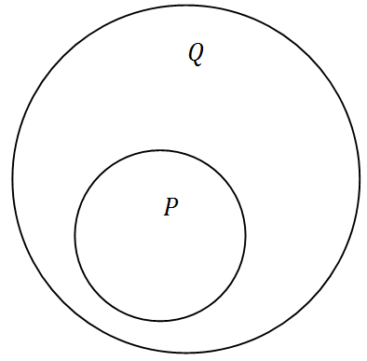
A mathematical set is just a group of things. The group can include anything: letters, numbers, objects or monkeys. Set theory focuses on the relationships between sets as they overlap or are completely within each other. For the purposes of if-then statements, set theory provides a perfect framework in which to reason.
Consider set P and set Q that are just collections of things represented by circles. If something is not in the set, then it is not in the circle.
In this case, set P is a subset of set Q since it is entirely included within set Q. Mathematically we write the statement “P is a subset of Q” as:
P⊆Q
This can be translated to an if-then statement, and simplified using symbols:
If it is an element in P, then it is an element in Q.
If P, then Q.
P→Q
If-then statements are examples of conditional statements. Sometimes conditional statements are written without an “if” or a “then”, but can be rewritten. The “if” part of the statement (represented by
P above) is called the hypothesis, antecedent or protasis. The “then” part of the statement (represented by Q above) is called the conclusion, consequent or apodosis.
In order to precisely define the truth value of a conditional statement, we need to consider the four different combinations of the truth value for P and Q in relation to the diagram.
If P is true, then Q is true. This statement is true because if an object is inside circle P, then it is definitely inside circle Q.
If P is true, then Q is false. This statement is false because there is no possible way an object could be inside circle P and yet outside circle Q.
If P is false, then Q is true. This statement is considered true because if an object is outside circle P then it may or may not be in circle Q. There is no contradiction.
If P is false, then Q is false. This statement is also considered true because if an object is outside circle P, then it can be outside circle Q. Like the previous statement, there is no contradiction.
Note that a conditional statement is only false when the hypothesis is true and the conclusion is false. Also note that any conditional statement with a false hypothesis is trivially true. The following statement is trivially true because the hypothesis is false.
If pigs can fly then butterflies eat elephants.
The truth of this statement confuses many people the first time they look at it. One way to frame it in your mind is to realize that a statement is false only when it results in a logical contradiction. In a world where pigs could fly perhaps butterflies could eat elephants, who knows? It would be ridiculous for a person to argue that in the hypothetical world where pigs could fly that there is no way that butterflies could eat elephants.

Examples

Example 1
Earlier, you were asked if it rained given the following two statements:
- If it rains today then you will stay at home and read a book.
- You stayed at home and read a book.
Use a diagram to represent the conditional statement.
If it rains today then you will stay at home and read a book.
- P= it rains today
- Q= you will stay at home and read a book.
You stayed at home and read a book. This implies that Q is true. According to the diagram, if an object is inside Q it may or may not be inside P. Thus, you can conclude nothing about the rain. Many people will want to incorrectly conclude that it must have rained, but conditional statements only flow in one direction.

Example 2
Rewrite the following conditional statements in if-then form.
- If you go to the show, you will be amazed.
- Unless you buy firewood you will be cold.
- Come here and you will get a present.
- Kicking a soccer ball makes it bounce.
- Give me your lunch money or I’ll put you in a locker.
- Anyone who wears orange likes Halloween.
- Without my sunglasses on I can’t drive.
- Buy this product and you’ll be beautiful and popular.
Even though these statements have words like “and”, “or” and “not” they are still just conditional statements. In each case, consider which action or event leads to another action or event.
- If you go to the show, then you will be amazed.
- If you do not buy firewood, then you will be cold.
- If you come here, then you will get a present.
- If you kick a soccer ball, then it will bounce.
- If you don’t give me your lunch money, then I’ll put you in a locker.
- If a person wears orange, then that person likes Halloween.
- If I do not wear my sunglasses, then I can’t drive.
- If you buy this product, then you will be beautiful and popular.

Example 3
Evaluate the truth value of the following conditional statement using a truth table.
If when I go somewhere I always run, then when I run I always go somewhere.
This statement actually has two layers of conditional statements because both the hypothesis and the conclusion are conditional statements themselves.
- Let R be the statement “I run”.
- Let S be the statement “I go somewhere”.
The original sentence can be rewritten in symbols as: (S→R)→(R→S). To make the truth table for the sentence, start with all possible truth combinations of S and R (both true, S true/R false, S false/R true, both false). Then, find the truth values for each piece working up to the full sentence.
S | R | S→R | R→S | (S→R)→(R→S)
T | T | T | T | T
T | F | F | T | T
F | T | T | F | F
F | F | T | T | T
The statement is always true unless you run but do not go anywhere.

Example 4
If all of the following statements are true, what can you conclude?
- All babies are cute.
- Laura likes cute people.
- Laura is a baby.
First translate each of the statements into conditional statements (even if they sound awkward!). This is helpful for determining an if-then chain of events.
- A: If a person is a baby then the person is cute.
- B: If a person is cute then Laura likes that person.
- C: If a person is named Laura then that person is a baby.
You should notice the circular structure of these three statements.
A→B,B→C,C→A
A→B→C→A
While many conclusions could be made, one conclusion about Laura is that she likes herself.

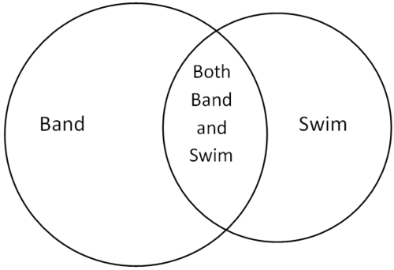
Example 5
There are 53 people in the marching band and 49 people on the swim team. If 84 people belong to either or both teams, how many people are on both teams?
While this problem is not specific to if-then statements, it can be solved using a set theory representation and if-then logic.
Students on both teams would be double counted if you simply added up the number of students in band and the number of students on the swim team.
53+49=102
Since there are only 84 people total, then 102−84=18 students must have been counted twice. Therefore, there are 18 students on both squads.

